**Lab 1: Common Emitter Amplifier**

**Introduction**

The objective of this lab was to design a common emitter amplifier that met the following specifications:

1. Gain > 33dB
2. Lower 3dB point < 100Hz
3. Upper 3dB point > 22KHz
4. ±1V output swing without distortion

The amplifier must also be beta independent

**Circuit Design**

In order to achieve beta independence, a common emitter amplifier with emitter degeneration was chosen (proved at the end). In order to increase the gain, a bypass capacitor was added across the resistor RE. In order to achieve minimal distortion, the gain was chosen to be 100, so that with a 10mV amplitude input, the output would be a 1V amplitude signal. IC was chosen to be .5mA. Rc was calculated as follows:

The collector voltage is also set to 2.5V by using a 5kΩ resistor with 0.5mA current. The emitter voltage was chosen to be 0.2V, to so with a collector current of 0.5mA, a 400Ω resistor was used to achieve the desired voltage. The bias point for the base was set to be 0.2 + 0.65 = 0.85V, because the Base-Emitter junction forms a diode with a voltage of 0.6V across it in the forward active region. To achieve this voltage, a voltage divider was used, with the lower part of the divider using a 2.2kΩ resistor and the upper part using a 10kΩ resistor. The current through the voltage divider is 5V/12.2kΩ = 0.41mA, which is more than 100 times greater than the current through the base, so the load from the transistor is negligible and can be ignored.



5

Figure : Schematic of the Common Emitter Amplifier

The capacitors Cblock and Cbypass were chosen to be sufficiently large enough so that the lower 3dB point would be less than 100 Hz. Their values were 100uF and 330uF. Capacitor Cout was chosen to be 10pF.

The circuit was then simulated in LTSPICE to check the transient solution and bode plot. The simulation results closely matched the hand calculations, so the circuit was built. The physical realization also closely matched the hand calculations for high frequencies, but the lower frequencies, close to 100Hz, were distorted. To fix this issue, the emitter resistor was split into two resistors, 350Ω and 51Ω, and the 350Ω was bypassed to provide a high gain (gain is now ~ Rc/Re, so new gain is approximately 100). The new circuit was simulated, and the gain was found to be reduced to 35dB (~56).



Figure :Schematic of the Common Emitter Amplifier with emitter degeneration and partial bypass



Figure : Transient simulation with 10mV input signal at 1KHz



Figure : Bode Plot analysis

The modified circuit was then built on a breadboard, and it’s performance was measured using an oscilloscope with 3 inputs: 100 Hz, 6KHz, and 22KHz. The gain was measured to be 34dB (Av = 50) at the two higher frequencies, but was still significantly lower (26dB) at 100Hz. After some debugging, the cause for the attenuation was identified to be the output capacitor. Once that capacitor was changed to a 10nF capacitor, the gain of the amplifier at 100Hz matched that of the higher frequencies.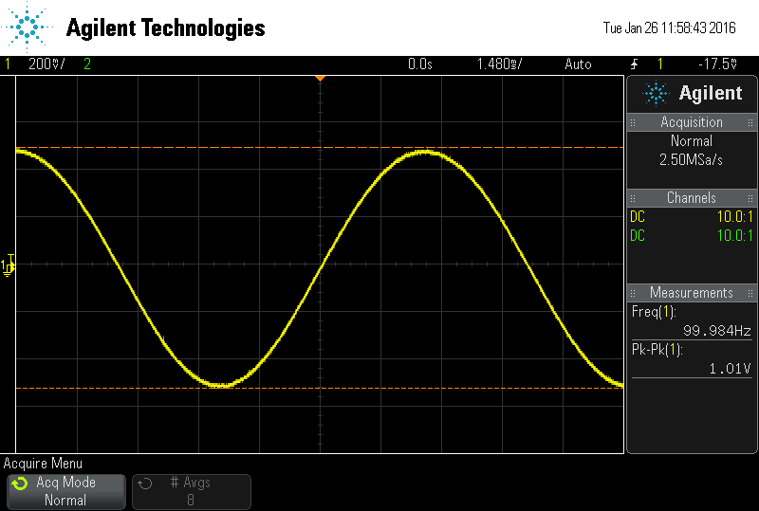

Figure : Output of the amplifier with 20mVpp 100Hz input

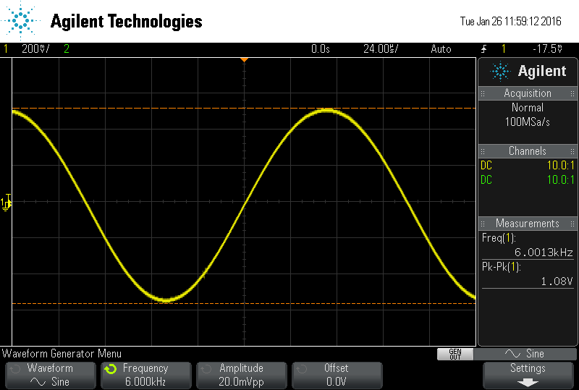

Figure : Output of the amplifier with a 20mVpp 6KHz input

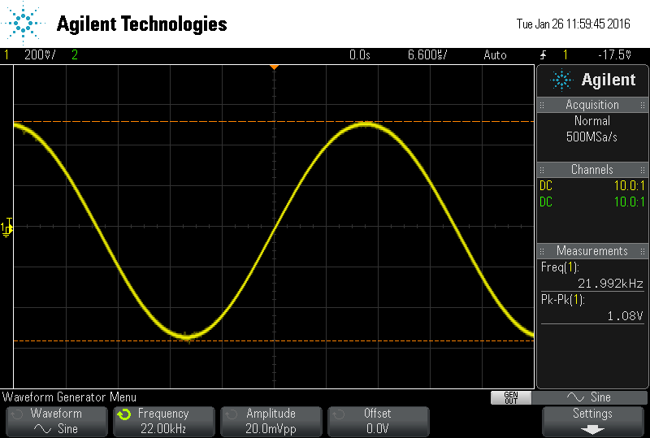

Figure : Output of the amplifier wiht a 20mVpp 22KHz input

**Beta Independence Proof**

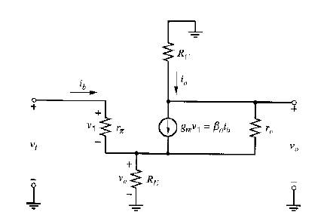

Figure : Small signal model of a common emitter amplifier with degeneration (from

*Assume ro >> RC ,RE*

*rπ << (β+1)RE*

Therefore the gain of this circuit is beta-independent.